Employee Turnover Analytics
Predicting and Preventing Employee Attrition using Machine Learning

Data-Driven HR Analytics Case Study

1. Business Problem
A large company (Portobello Tech) is facing a high rate of employee attrition. Losing skilled employees is costly: hiring, onboarding, and lost productivity all add up. The goal of this project is to understand WHY employees leave and to build a predictive model that flags employees who are at risk of leaving — so HR can intervene before it happens.
- Dataset: HR_comma_sep.csv — 14,999 employee records, 10 columns, no missing values.
- Target variable: left (1 = employee left, 0 = employee stayed).
- Class distribution: 11,428 stayed (76.2%) vs. 3,571 left (23.8%) — an imbalanced target.

Dataset Features
Column | Type | Description
satisfaction_level | Numeric (0–1) | Employee satisfaction score
last_evaluation | Numeric (0–1) | Last performance evaluation score
number_project | Numeric | Number of projects assigned
average_montly_hours | Numeric | Average monthly working hours
time_spend_company | Numeric | Years spent at the company
Work_accident | Binary | Had a workplace accident
left | Binary (target) | Whether the employee left
promotion_last_5years | Binary | Promoted in the last 5 years
sales | Categorical | Department (10 categories)
salary | Categorical | Salary level: low / medium / high

2. Exploratory Data Analysis

2.1 Correlation with Turnover
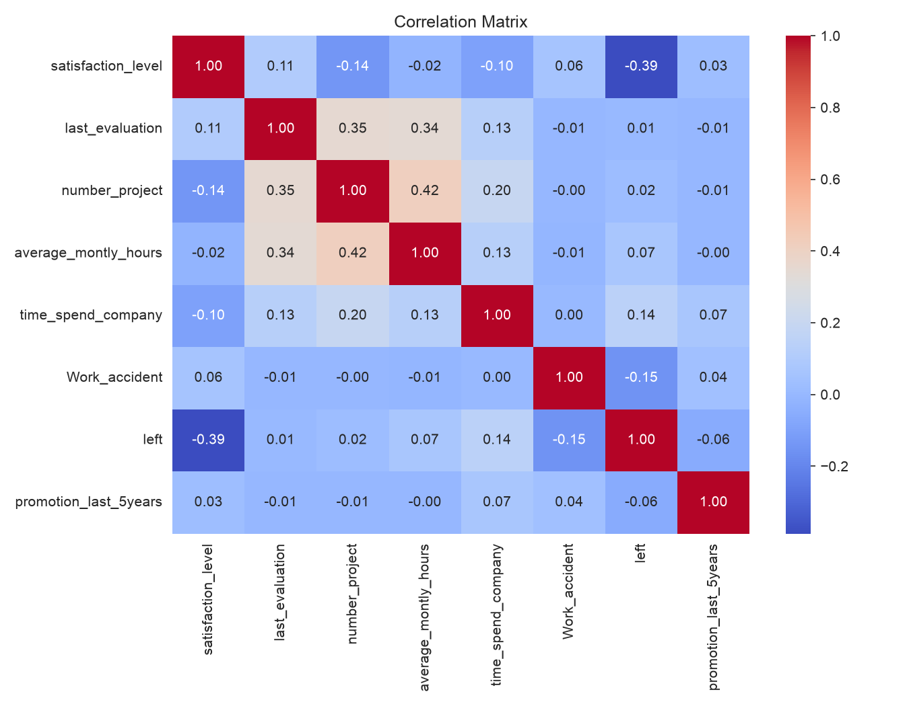
satisfaction_level has by far the strongest correlation with attrition (-0.39) — lower satisfaction is strongly linked to leaving. Work_accident (-0.15) and time_spend_company (+0.14) show weaker effects. Other numeric features (number_project, last_evaluation) show almost no direct linear correlation with leaving, hinting that the real relationships are non-linear.

2.2 Workload vs. Turnover — a U-Shaped Relationship
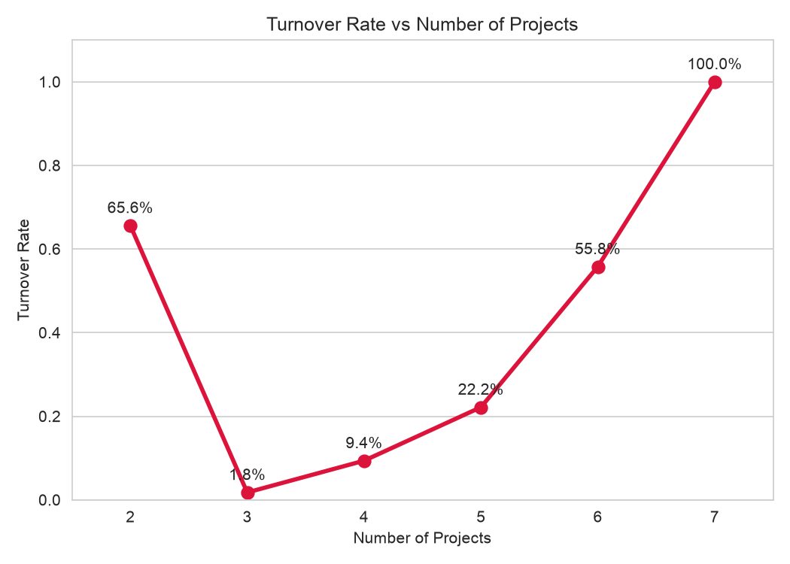
Projects | Turnover Rate
2 | 65.6%
3 | 1.8%
4 | 9.4%
5 | 22.2%
6 | 55.8%
7 | 100%
Turnover is highest at BOTH extremes of workload: employees with only 2 projects (likely disengaged/underutilized) and employees with 6–7 projects (likely overloaded/burned out) leave at much higher rates. The lowest turnover (1.8%–9.4%) occurs at 3–4 projects — the optimal workload zone. This directly disproves the simplistic idea that “more projects always means more attrition.”

3. Clustering Employees Who Left
K-Means clustering (k=3) was applied to satisfaction_level and last_evaluation, restricted only to employees who left, to understand WHY different groups of people leave.
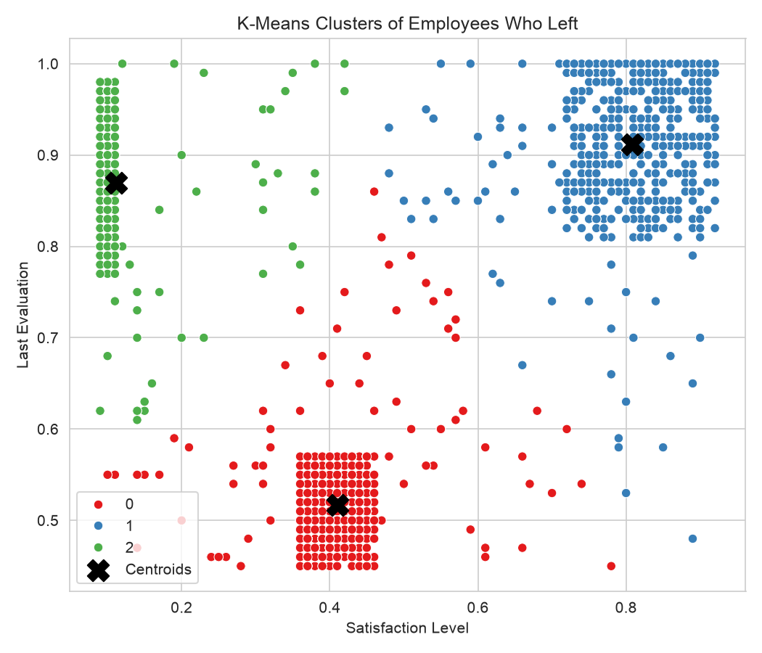
Cluster | Avg. Satisfaction | Avg. Evaluation | Employees | Profile
0 | 0.41 | 0.52 | 1,650 | Poor performers, unhappy — expected/low-concern churn
1 | 0.81 | 0.91 | 977 | Happy, high performers — likely poached / better offer
2 | 0.11 | 0.87 | 944 | Miserable, high performers — likely burnout, most preventable
Key insight: satisfaction and performance are NOT correlated among leavers. There are both a happy high-performer cluster and a miserable high-performer cluster — meaning high performance alone does not predict retention. This distinction matters directly for designing retention strategies (see Section 7).

4. Data Preparation for Modeling
- Categorical columns (sales, salary) converted to numeric using one-hot encoding (pd.get_dummies, drop_first=True) — 8 numeric + 11 dummy columns = 19 total features.
- Stratified 80:20 train/test split (random_state=123) — preserves the 76/24 class ratio in both sets.
- Class imbalance in the training set corrected using SMOTE (Synthetic Minority Oversampling Technique) — balances the minority class (left=1) by generating synthetic samples, applied ONLY to the training data (never the test set, to avoid data leakage).

5. Model Building and Evaluation
Three classifiers were trained on the SMOTE-balanced training data and evaluated on the untouched, realistic (imbalanced) test set: Logistic Regression, Random Forest, and Gradient Boosting.

5.1 ROC Curve Comparison
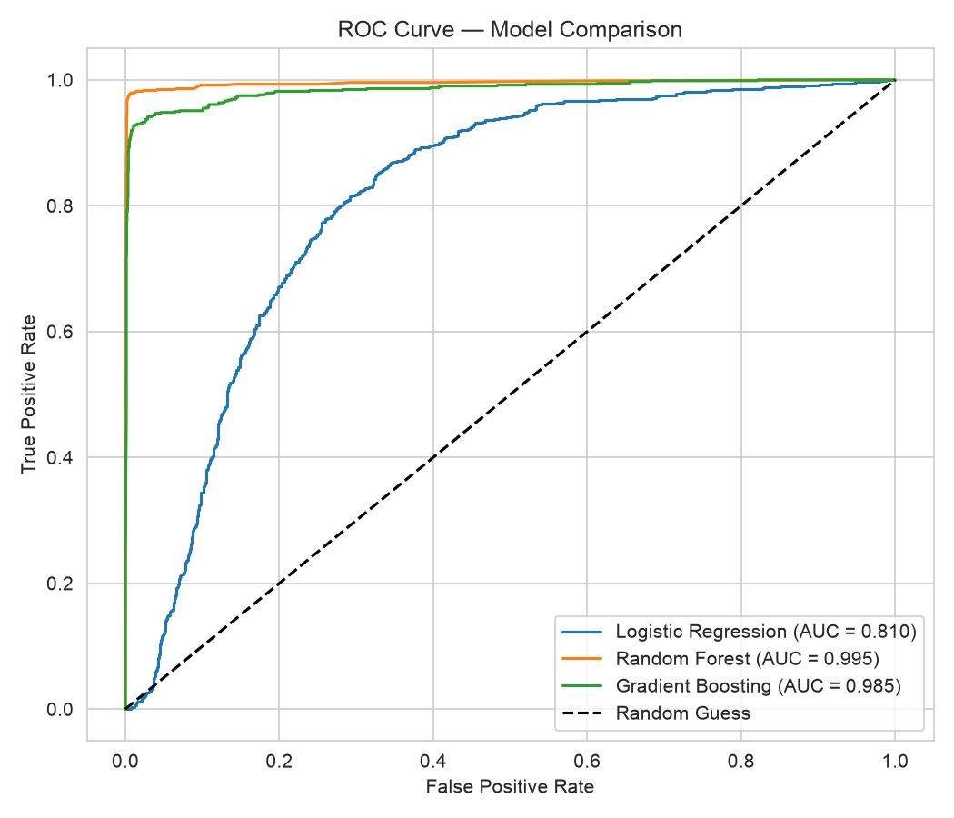

5.2 Performance Summary
Model | Accuracy | Precision | Recall | F1 | AUC
Logistic Regression | 0.752 | 0.486 | 0.751 | 0.590 | 0.810
Random Forest | 0.988 | 0.971 | 0.979 | 0.975 | 0.995
Gradient Boosting | 0.963 | 0.911 | 0.937 | 0.924 | 0.985

5.3 Confusion Matrices
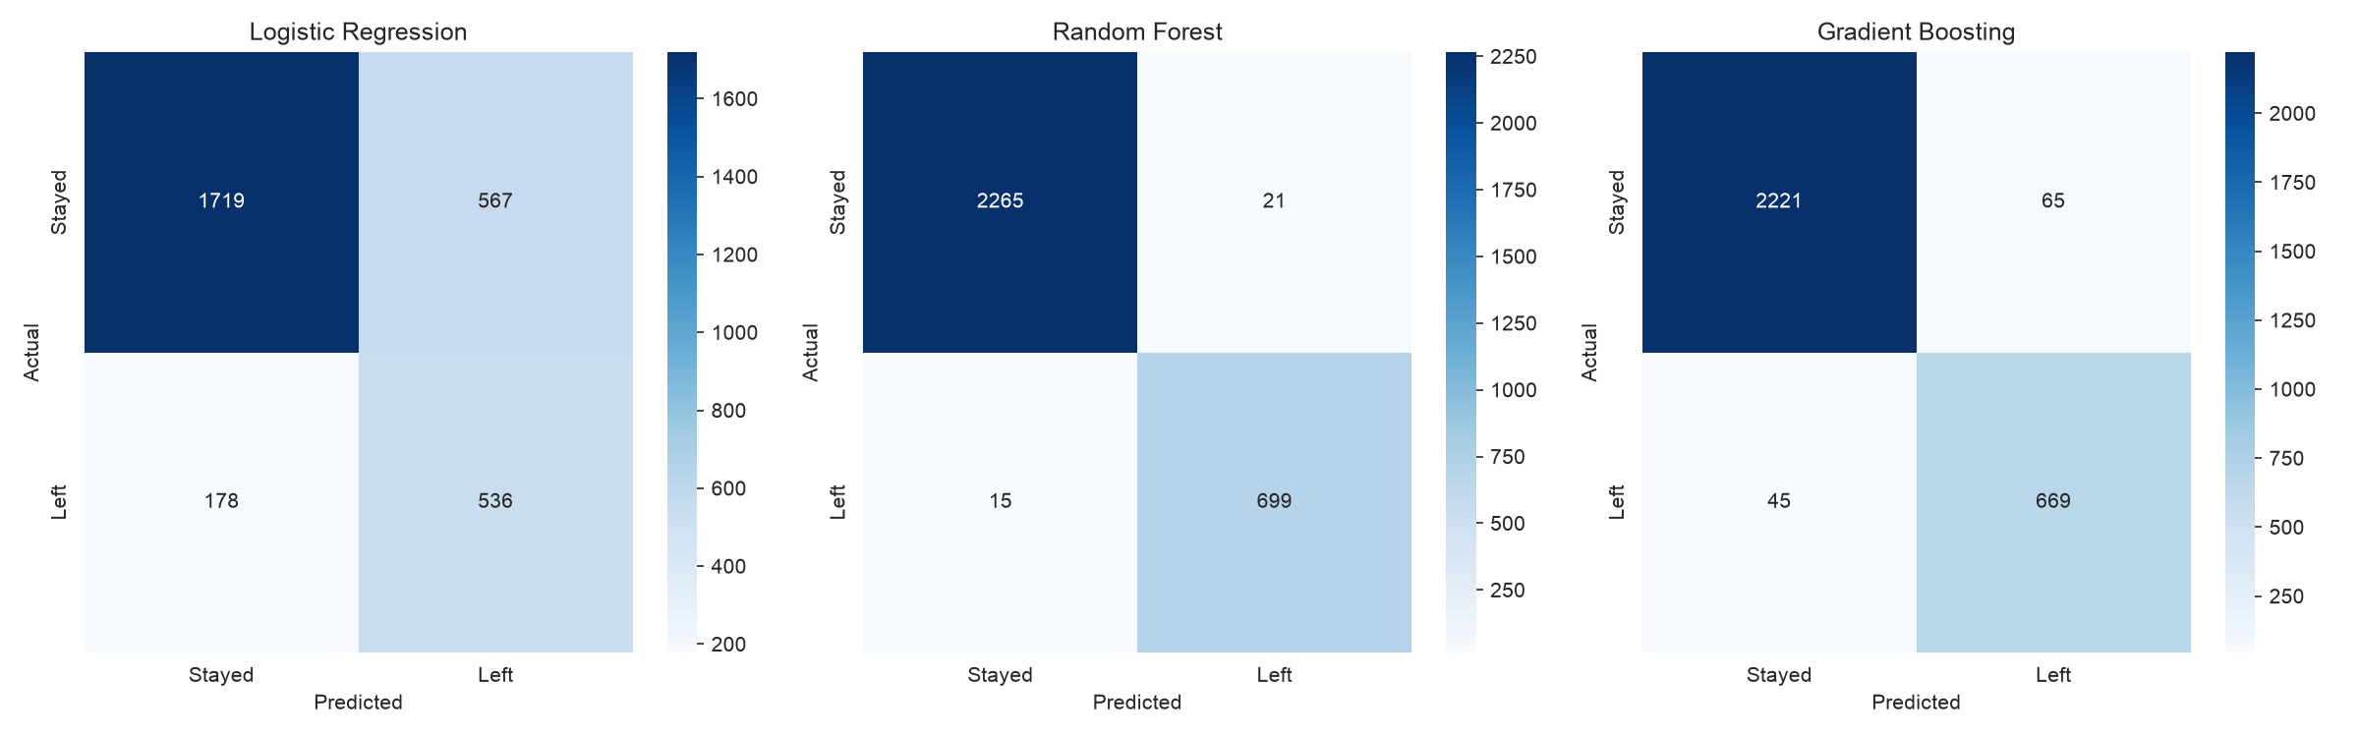

5.4 Why Recall Matters More Than Precision
In this problem, a False Negative (missing an employee who is actually about to leave) is far more costly than a False Positive (flagging a stayer as at-risk, resulting in an unnecessary check-in). Therefore Recall on the 'left' class is the metric that should be optimized, not Precision or raw Accuracy alone (accuracy is also misleading here due to class imbalance — a model predicting “stayed” for everyone would already score ~76%).

5.5 Best Model: Random Forest
Random Forest wins on every metric — Accuracy, Precision, Recall, F1, and AUC — and has by far the fewest false negatives (15, vs. 178 for Logistic Regression and 45 for Gradient Boosting). It captures the non-linear patterns in this data (like the U-shaped workload effect and the two opposite high-performer clusters) that a linear model like Logistic Regression cannot.

6. Predicting Turnover Risk
Using the Random Forest model, every test-set employee is assigned a predicted probability of leaving, then segmented into four actionable risk zones.
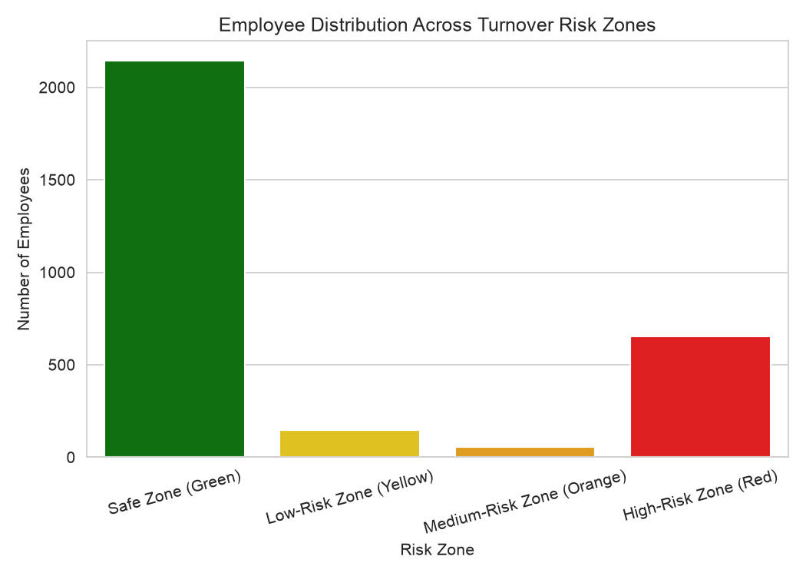
Zone | Probability Range | Employees
Safe Zone (Green) | < 20% | 2,144
Low-Risk Zone (Yellow) | 20% – 60% | 148
Medium-Risk Zone (Orange) | 60% – 90% | 56
High-Risk Zone (Red) | > 90% | 652

7. Retention Strategy Recommendations

Safe Zone (Green)
No action needed. Continue standard engagement: regular 1:1s, recognition, normal career development conversations.

Low-Risk Zone (Yellow)
Light-touch, proactive monitoring. Check in periodically on satisfaction and workload; watch for early warning signs such as rising average_montly_hours or stagnant number_project.

Medium-Risk Zone (Orange)
Direct manager intervention. Discuss workload balance explicitly (both very low and very high project counts drive attrition); review salary/promotion standing and recent evaluation feedback.

High-Risk Zone (Red)
Urgent, senior-level retention action — this is the largest at-risk group (652 employees). Immediate 1:1 with HR/leadership, consider salary revision or promotion, workload reassignment, or a counter-offer conversation.

Tailoring by Root Cause (using the K-Means clusters)
- Happy-but-left profile (high satisfaction + high evaluation): likely leaving for external opportunity — a promotion, raise, or expanded role may retain them.
- Miserable-high-performer profile (low satisfaction + high evaluation): likely burnout-driven — reducing workload or project count is more relevant than a raise.
Applying the same retention offer to both groups would be inefficient — interventions should match the underlying reason for risk, not just the risk score.

8. Conclusion
- Satisfaction level is the single strongest driver of attrition; workload (number_project) has a U-shaped, non-linear relationship with turnover.
- Employees who leave fall into at least 3 distinct behavioral clusters, not one uniform group — retention strategy must differ by cluster.
- Random Forest (Accuracy 98.8%, Recall 97.9%, AUC 0.995) is the recommended production model, clearly outperforming Logistic Regression and Gradient Boosting on every metric.
- A 4-tier risk-zone framework (Green/Yellow/Orange/Red) converts model probabilities into a practical, actionable HR playbook.

Next Steps
- Deploy the Random Forest model to score active employees on a recurring basis (e.g. monthly).
- Integrate risk-zone alerts into HR dashboards for proactive manager action.
- Periodically retrain the model as new attrition data becomes available.

